Let's summarise the points discussed in the video.

**Comparison**

These charts can be used when you want to compare one set of values with other sets of values. The objective is to differentiate one particular set of values from the other sets, for example, quarterly sales of competing phones in the market. The following two types of charts are used to show a comparison:

1. Column Chart

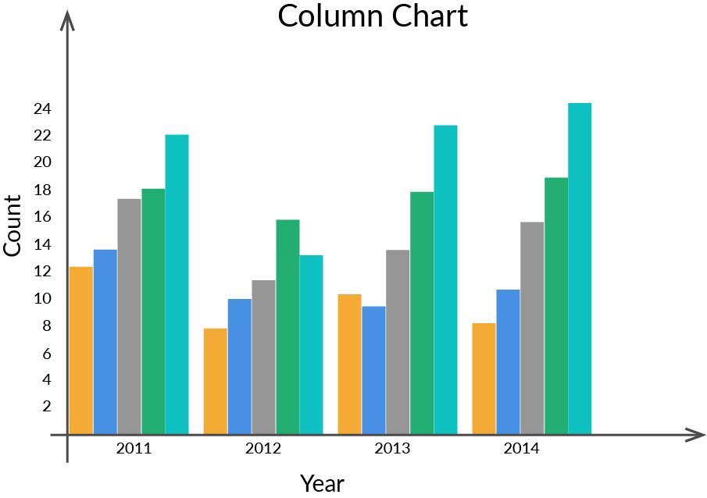

2. Bar chart

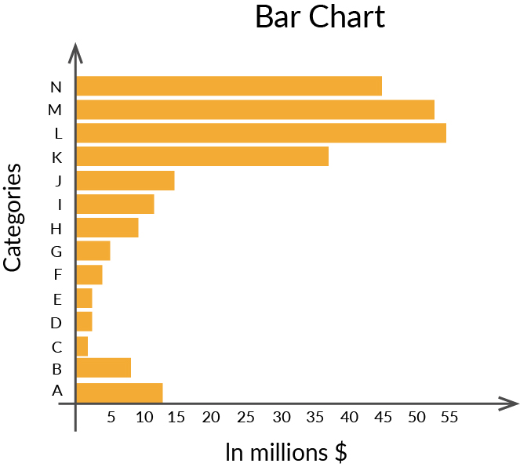

**Composition**

You would need to use a composition chart to display how the various elements make up the complete data. Composition charts can be static, which shows the composition at a particular instance of time, or dynamic, which shows the changes in the composition over a period of time. Two of the popular composition charts are as follows:

1. Pie/ Doughnut Chart  
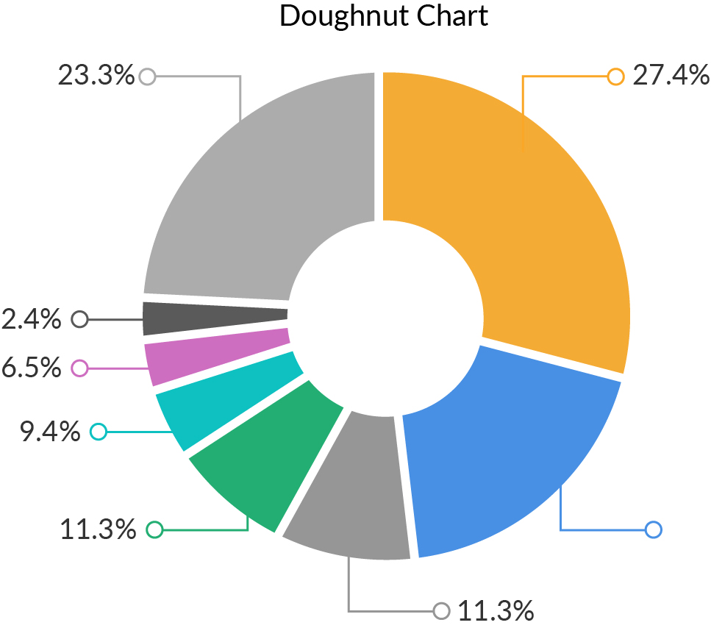

2. Stacked Column chart

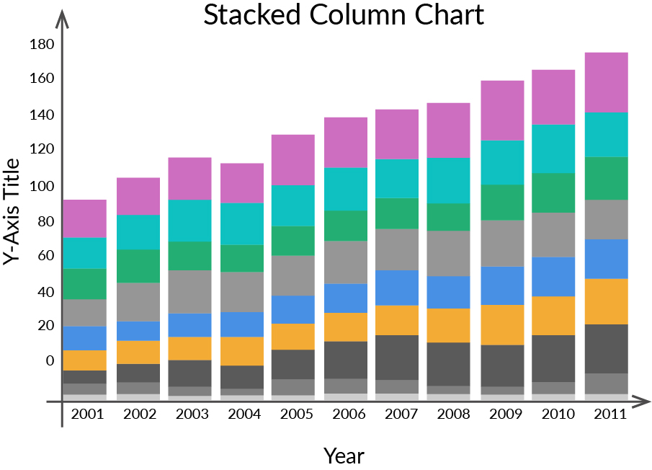

The pie chart is by far the most common way to represent static composition, while the stacked column chart can be used to show the variation of composition over a period of time.

**Relationship**

A relationship chart helps in visualising the correlation between variables. It can help in answering questions such as ‘Is there a correlation between the amount spent on marketing and the sales revenue?’ and ‘How does the gross profit vary with the change in offers?’. Two of the most common types of charts used to visualise relationships between variables are as follows:

1. Scatter plot

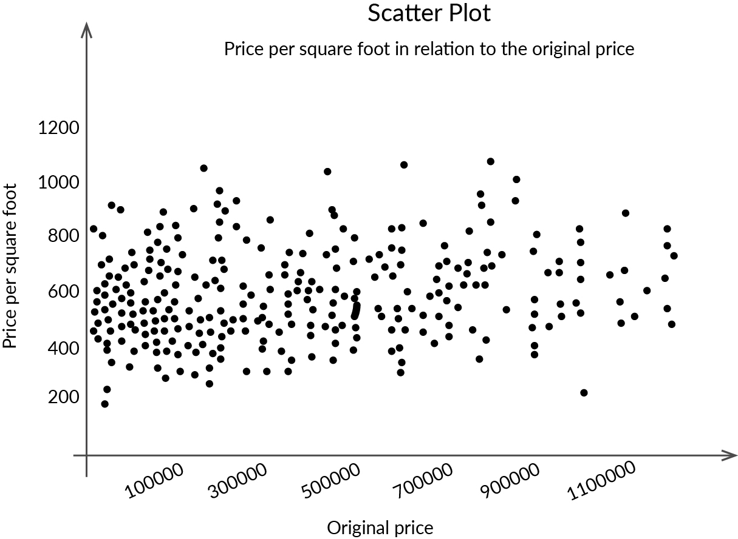

2. Bubble Plot

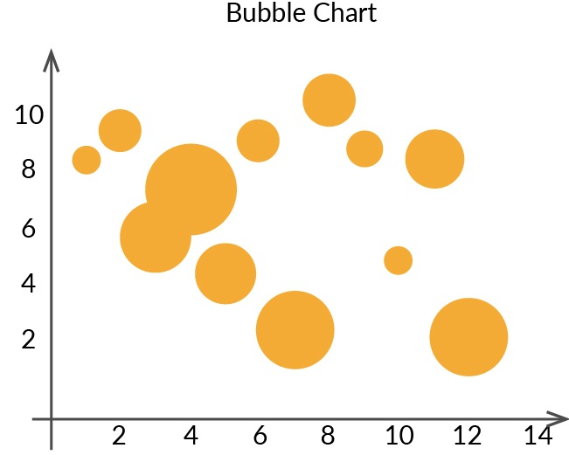

A scatter plot can help correlate two variables, whereas a bubble chart adds one more dimension, i.e., the size of the bubble (usually indicative of the frequency of occurrence of that particular data point)

**Distribution**

A distribution chart tries to answer the question ‘How is the data distributed?’. For example, suppose you asked everyone their age in a survey. Using a distribution chart will help you visualise the distribution of ages in the data set. The distribution can be over a variable, or it can also be over a period of time. Two of the most commonly used charts for visualising distribution are as follows:

1. Histogram

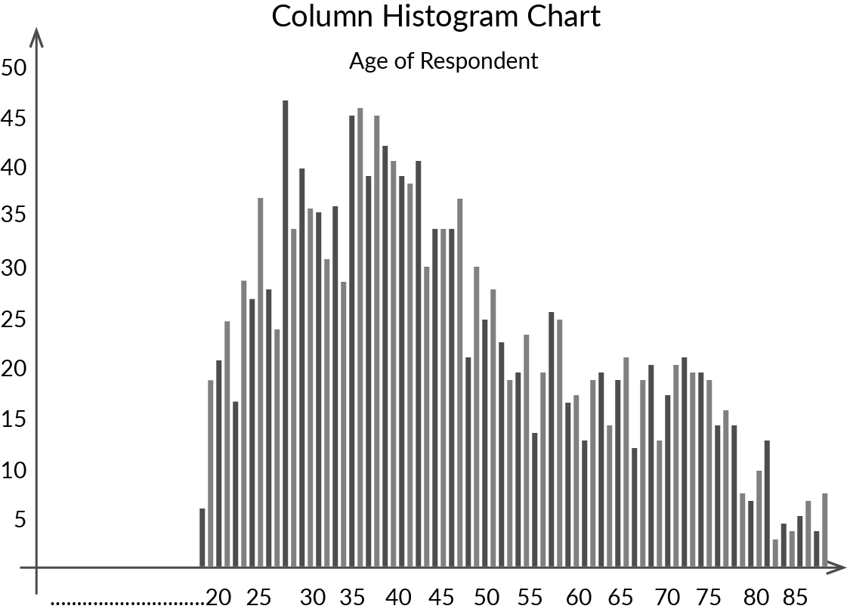

2. Scatter plots



Histograms are quite good at displaying the distribution of data over intervals, whereas scatter plots are good at visualising the distribution of data over two different variables.

These are the most common objectives of data visualisation, and the aforementioned types of charts help in achieving these objectives. However, this list is not exhaustive; you can always find more goals to create a visualisation. One of the key takeaways from this segment is to observe the chart that you have prepared and check whether it serves the purpose for which it was created. If it does serve the purpose, then you have created the right type of chart. If it doesn't, then you need to try other options to make the message of the chart very clear.

You can apply your learnings from this segment in the practice notebook attached below.

**Additional References:**

You can refer to the links provided below to learn more about visualisation:

1. You can go to this [link](https://gramener.com/posters/Winning-Parties.pdf) from Gramener to know how data visualisation can help you derive insights about the winning political parties in India.

2. You can view this [link](https://blog.socialcops.com/open-data/aging-population) from SocialCops to see a creative visualisation on the ageing world population.

3. You can refer to this [link](https://blog.hubspot.com/marketing/data-visualization-choosing-chart#sm.000vodl7ch6rf7e112a2q13r9cno0) to learn how to choose a graph plot for your data.

4. You can refer to this [link](http://www.youtube.com/watch?v=UO98lJQ3QGI&list=PL-osiE80TeTvipOqomVEeZ1HRrcEvtZB_) to find additional video tutorials by Corey Shaffer on Matplotlib.

5. You can refer to this [link](https://matplotlib.org/3.2.1/tutorials/index.html)to find **official Matplotlib Documentation**

6. You can learn more about choosing the right plot type by referring to this [link](https://chartio.com/learn/charts/how-to-choose-data-visualization/).

7. You can refer to this [link](https://www.youtube.com/watch?v=Ercd-Ip5PfQ)to find out additional information about plotting real-time data.